Newton’s Laws
Michael Fowler Physics 142E Lec 6 Jan 22, 2009

Newton’s Imaginary Cannon
Newton was familiar with Galileo’s analysis of projectile motion, and decided to take it one step further. He imagined putting the cannon on top of a very high mountain and pouring in more and more gunpowder so the ball flew further and further:
Here’s his own drawing:
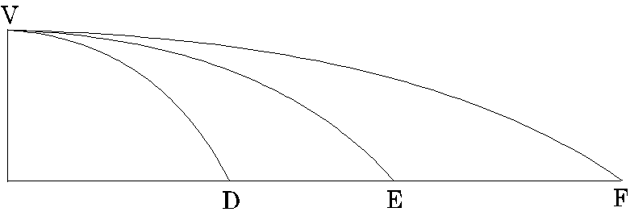
Remember that the time the cannonball takes to reach F is the same as it took to reach E and D: just equal to the time it would take if dropped from V to the level ground.
To continue Newton’s fantasy, consider now the cannon to be placed on a mountain so high that air resistance is completely negligible even at these high cannonball speeds (no such mountain exists, but any mountain at all would do on the Moon!)
Now, irrespective of horizontal speed, the cannonball drops almost exactly 5 meters in the first second. BUT if it’s going fast enough, it’ll get so far that the curvature of the Earth can’t be ignored!
The Earth’s surface will have fallen below a horizontal line too. What we have to find is the distance over which the curving Earth’s surface drops below a horizontal line by 5 meters, because if the cannonball can get that far in one second, it won’t have lost any height, relative to the ground.
This is an exercise in Pythagoras’s Theorem—look at the diagram:
R
R + 5
v
Using Pythagoras’s Theorem to find over what distance v the Earth’s surface falls below a horizontal tangent line by 5 meters: (R + 5)² = R² + v². (R in meters)
Newton knew the radius of the Earth was 6400 km (in some units—actually he began with an incorrect value, and put aside his result, but that’s irrelevant to us now, he got it right a little later) , so
(R + 5)² = R² + v²
or
R ² + 10R + 25 = R² + v².
Notice that R² appears on both sides, so can be dropped, and also the 25 is completely negligible compared with 10R, so we drop it too, to find:
v² = 10R = 10×6400×1000 = 64 × 1,000,000, so v = 8,000m = 8 km.
Remember here we’re using v to represent the distance the cannonball must fly in one second for its falling below a horizontal line to match the Earth’s surface’s falling below a horizontal line.
The bottom line is that a cannonball fired at a velocity v = 8 km/sec will not lose altitude.
You might be thinking: but what happens in the next second? The answer is: exactly what happened in the first second! It’s like a fresh start—the cannonball is horizontal to the level ground now below it, and gravity, always directly downwards, has turned a little too. And, this scenario repeats indefinitely, provided air resistance is completely negligible. The cannonball is in orbit!
Newton understood this point completely, and drew a diagram to make it clear:
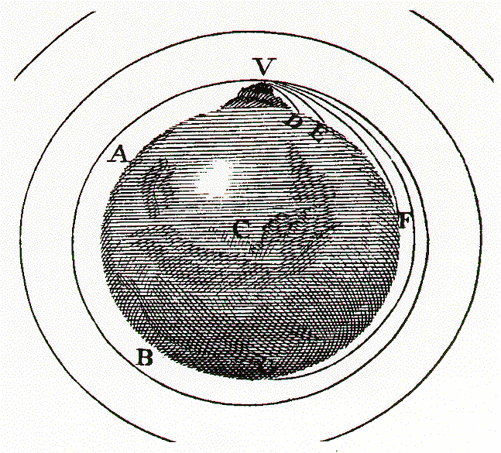
For an animated version of Newton’s cannon on a mountain, click here!
Of course, no such mountain exists, but that no longer matters: we can get a satellite up there, going at the appropriate speed, and it takes years for the air resistance to bring it down (from, say, 120 miles up, where some of the first satellites were placed, they’re now mostly 200 miles and above). And, Newton got the orbital speed right: the lowest earth orbit satellites go once around in about 90 minutes. (Note for nitpickers: as we’ll discuss later, at a height of 120 miles, g is down to about 9.2, so the 5 meter fall should more accurately be 4.6m.)

On to the Moon
Once Newton realized that gravity could hold a cannonball in a circular orbit indefinitely, it dawned on him that the Moon must be circling the Earth for exactly the same reason—not to mention the planets orbiting the Sun, etc. (Look at the other circles on his diagram above—they’re possible orbits.)
Does this mean the Moon’s circular orbit falls below a straight-line tangent by 5 meters in one second?
To find out, we can follow exactly the procedure we used above to find v, but now in reverse: we know the Moon’s speed in orbit, since it goes completely around in 27.3 days, and the radius of the orbit, 384,000 km, was already known to the ancient Greeks. So it’s just Pythagoras again: the Moon’s velocity in orbit turns out to be almost exactly 1 km/sec, if it falls x m below a straight line in one second,
2xR = v²,
and we find x = 1.37 mm—far less than 5 meters!
But this was the key to gravity: the ratio of the distances fallen by the cannonball and the Moon would be the ratio of the acceleration due to gravity at the Earth’s surface and at the distance of the Moon. Now, the Moon is 60 times further from the center of the Earth than we are, and the distance theMoon “falls” in one second, the 1.37 mm, turns out to be 1/3600 of 5 meters—and 1/3600 = (1/60)².
Newton concluded that the gravitational acceleration of an object towards the Earth diminishes as the inverse square of the distance between them, as 1/r².

Acceleration in Circular Motion
Our above result for the distance fallen below a horizontal line in motion at speed v around a circle of radius R, 2xR = v² is completely general, in the limit of small distance traveled relative to the radius.
Note now that the distance fallen x can be expressed in terms of the downward acceleration a as x = ½at², and since the time is one second (the distance traveled was v) , x = ½a. Putting this together with 2xR = v², we find the acceleration in circular motion
a = v²/R
towards the center of the circle. This is an extremely important result: this acceleration is for a body moving at constant speed, and is entirely caused by changing direction.
Furthermore, it is acceleration towards a point the body never gets any closer to! Fully understanding acceleration is half the battle in understanding Newtonian mechanics.
Always remember that acceleration is a vector quantity, and its direction has nothing to do with the direction of the velocity at the same instant—all that matters is the difference between the velocity vector and that at a slightly different time .

From Galileo’s Laws of Motion to Newton’s: Introducing Force

Newton’s First Law: the Law of Inertia
Recall Galileo had two “laws of motion” : vertical motion was at constant acceleration, horizontal motion at constant velocity, always provided no frictional forces (including air resistance) were present. Recall also that a projectile motion could be analyzed in terms of a gravitational falling away from a straight line trajectory:
Motion under gravity of a cannonball shot at an angle:
0
x
y
Newton’s great insight was to realize that gravity is a force, just as real as the force of air resistance, and if there were truly no force on the projectile it would continue in a straight line forever.
People at the time had a hard time accepting this: their idea of a force was a direct, in-contact, push of pull, or, say, friction dragging something pushed along the ground. The idea of the Earth exerting a force through empty space, without physical contact, seemed creepy: they were trying to get away from magic and superstition, and this seemed a backward step. Newton wasn’t keen on it, either, he offered no ideas on how it might come about, he just stated that there it was: introducing this force gave—for the first time—a unified picture of motion that included things here on Earth and the solar system above.
Newton’s First Law of Motion tells what happens if a moving body feels no force at all: no friction, no air resistance, no gravity.
A body stays at rest, or moving at constant velocity, if there are no forces acting on it. In particular, a projectile will keep moving in a straight line at constant speed under these conditions.
This is sometimes called “The Law of Inertia”: it’s a generalization of Galileo’s natural horizontal motion, and we can now see that the projectile diagram above the force of gravity gives the deviation from a straight line.
So any acceleration, or change in speed or direction of motion of a body signals that it is being acted on by some force.

Newton’s Second Law: Mass × Acceleration is Proportional to Force
Newton’s next assertion, based on much experiment and observation, is that, for a given body, the acceleration produced is proportional to the strength of the external force: doubling the external force will cause the body to pick up speed twice as fast, .
But what about different bodies, with different masses? A point well-established by this time was that if a force caused a body to accelerate at , the same force would accelerate two such bodies held together at . In other words, the acceleration for a given force was inversely proportional to the mass, where here mass really is just the amount of stuff. For a uniform material, the mass is the volume multiplied by the density: for water, that’s one kilogram per liter of volume, or one gram per cc.
Mass, then, can be thought of as resistance to having velocity changed by an external force. This “resistance” is also termed inertia. We can now put together and for a given force to give We already have units for mass (kg) and acceleration (m. sec⁻²).
We define our unit force as one Newton: the force that accelerates one kg at one meter per sec per sec. With force measured in Newtons, the equation becomes:
Newton wrote his Second Law slightly differently from this: he defined the “amount of motion” as what is now called the momentum, , and stated (in our notation):
This is of course the same as if the mass is constant, but also covers the case of changing masses, such as a rocket ejecting fuel, or a particle moving close to the speed of light. We’ll talk a lot more about momentum later.

The Force of Gravity: Mass and Weight
We’re ready to go back to falling bodies. Newton interpreted Galileo’s constant acceleration “natural vertical motion” as acceleration caused by a gravitational force, just as horizontal acceleration must be caused by an applied external force.
But the gravitational force has a special feature: all masses accelerate downwards at the same rate. This must mean that the gravitational force is proportional to the mass of the object.
The gravitational force on an object near the Earth’s surface is called its weight, so we’re saying weight is proportional to mass. Denoting weight as W, with all forces downward, F = ma is just W = mg, where g is the acceleration of a falling body. In physics problems, weight must be measured in its correct units, Newtons, although it is usually given in mass units in everyday life.
The gravitational force is not only proportional to the mass of the falling object: it must also be proportional to the mass of the Earth, because if there were two Earths glued together, surely the Moon would feel twice the attraction. The Moon is also gravitationally attracting the Earth: this is evident from the tides, which follow a monthly cycle as the Moon goes around, the water being pulled from its spherical shape.
Newton boldly generalized to the whole Universe:
he asserted that every body attracts every other body with a force proportional to both masses, and inversely proportional to the distance between them. Written as an equation,
where G is a constant to be determined. (We can’t set it equal to one: we already have units for mass, length and force.)
The force is along the line from the center of one body to that of the other, and each body is attracted towards the other. We’ll discuss gravity in more detail later: we’ve introduced it here because it is central to a full understanding of Newton’s Third Law.

Newton’s Third Law: Action and Reaction
Having established that a force—the action of another body—was necessary to cause a body to change its state of motion, Newton made one further crucial observation: such forces always arise as a mutual interaction of two bodies, and the other body also feels the force, but in the opposite direction.
His Third Law of Motion:
If a body A exerts a force on a body B, then the body B exerts a force on the body A.
This he wrote as:
To every action there is always opposed an equal and opposite reaction: or the mutual actions of two bodies upon each other are always equal in magnitude, but opposite in direction.
It doesn’t matter what kind of force we’re talking about: the Third Law is equally valid for pushing against a table, dragging a dog on a leash, or gravitational attraction. If you push against a wall, the wall is pushing you back. If that’s difficult to visualize, imagine what would happen if the wall suddenly evaporated.

Newton’s Laws in Everyday Life
The reason the external force causing the acceleration may not be immediately evident in a given situation is that it may not be what’s doing the work.
Consider the following scenario: you are standing on level ground, on roller skates, facing a wall with your palms pressed against it. You push against the wall, and roll away backwards. You accelerated. Clearly, you did the work that caused the acceleration. But from Newton’s Second Law, your acceleration was, in fact, caused by the reactive external force of the wall pushing your hands, and hence the rest of you.
That is to say, the force causing the acceleration may not be generated directly by what—or who—is doing the work! In this example, it’s generated indirectly, as a reaction force to that of the hands pushing on the wall. But if the wall were on wheels, and it accelerated away when you pushed (having taken off your roller skates) the force causing the acceleration of the wall would be generated directly by the agent doing the work, you.
Now imagine two people on roller skates, standing close facing each other, palms raised and pushing the other person away. According to Newton’s discussion above following his Third Law, the two bodies involved will undergo equal changes of motion, but to contrary parts, that is, in opposite directions. That sounds reasonable. They obviously both move off backwards. Notice, however, that Newton makes a special point of the fact that these equal (but opposite) “motions” do not imply equal (but opposite) velocities—this becomes obvious when you imagine the experiment with a 100 pound person and a 200 pound person. Newton tells us that in that situation the heavier person will roll backwards at half the speed—notice he says the velocities are “reciprocally proportional to the bodies”.
Roller skates actually provide a pretty good example of the necessity of generating an external force if you want to accelerate. If you keep the skates pointing strictly forwards, and only the wheels are in contact with the ground, it’s difficult to get going. The way you start is to turn the skates some, so that there is some sideways push on the wheels. Since the wheels can’t turn sideways, you are thus able to push against the ground, and therefore it is pushing you—you’ve managed to generate the necessary external force to accelerate you. Note that if the wheels were to be replaced by ball bearings somehow, you wouldn’t get anywhere, unless you provided some other way for the ground to push you, such as a ski pole, or maybe twisting your foot so that some fixed part of the skate contacted the ground.

