Projectiles
Michael Fowler 142E Lec 5 24 Jan 2009

Horizontal Motion
We spent a lecture describing how Galileo revolutionized thinking about vertical motion, and establishing by rolling a ball down a ramp that falling bodies pick up downward velocity at a constant rate, always neglecting air resistance. But what about horizontal motion? The orthodox view before Galileo was that, in contrast to falling, which occurred naturally in objects free to move, something only moved horizontally if it was alive, or being pushed or pulled. This would be a reasonable conclusion from observing a horse and cart crossing a field, or, say, pushing a box across the floor. But arrows keep moving after they’ve left the bow, and this was hard to explain: it was thought that as the arrow moved forward it would tend to leave a vacuum behind it, but nature didn’t like a vacuum, so air rushed in to fill the space, and this inrushing air pushed the arrow and kept it going. Galileo didn’t buy any of this nonsense: he noted that a ball rolling on a smooth horizontal plane kept going a long time, and the harder and smoother the plane and ball were, the longer it rolled.
Galileo concluded that, just as constant downward acceleration described natural vertical motion, neglecting air resistance, natural horizontal motion, again neglecting air resistance and friction, is motion at a constant velocity. Attempts to make friction smaller and smaller got closer and closer to this ideal motion. Before Galileo, the accepted position was that the only natural horizontal motion was no motion at all: an external force of some kind had to be introduced to keep something moving.
Galileo made the bold assertion that horizontal motion at a constant velocity was just as natural as being at rest, and an object would stay that way unless an external force acted: the friction or air resistance.

Compound Motion
The great breakthrough in understanding the path of a projectile came when Galileo suggested the motion could be understood as being made up of his natural vertical motion—constant downward acceleration—and his natural horizontal motion, constant horizontal velocity.
How can this suggestion be tested experimentally?
The suggestion that the vertical motion is independent of the horizontal motion means that if a ball rolls at some speed off the edge of a table, it takes exactly the same time after leaving the table to reach the floor as a ball simply dropped from the edge of the table. We have a demo of this: a device that shoots a ball horizontally simultaneously with dropping one from the same height. This confirms Galileo’s idea: the balls arrive at the floor together, and we can try it from different heights

But is the horizontal motion of a projectile at constant velocity? We can check this with the train demo, which shoots a ball upwards as the train moves along at close to constant velocity, then it catches the ball, which flew along at the same horizontal rate as the train.
What does this compound motion look like? Galileo himself drew a picture of the motion of a ball rolling off the end of a table, or, what amounts to the same thing, a cannon fired horizontally from the top of a cliff.
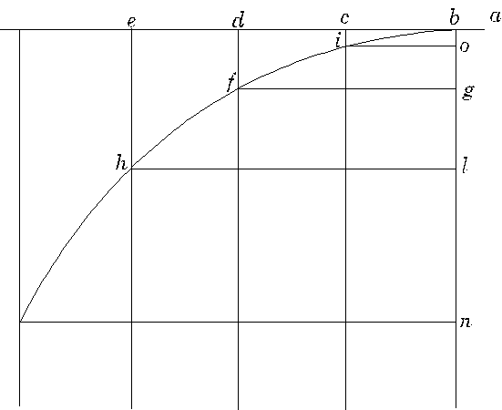

The simplest way to see what is going on is to study Galileo’s diagram which we reproduce here. For an animation, click here!
Imagine the ball to have been rolling across a tabletop moving to the left, passing the point a and then going off the edge at the point b. Galileo’s figure shows its subsequent position at three equal time intervals, say, 0.1 seconds, 0.2 seconds and 0.3 seconds after leaving the table, when it will be at i, f, and h respectively.
The first point to notice is that the horizontal distance it has travelled from the table increases uniformly with time: bd is just twice bc, and so on. That is to say, its horizontal motion is just the same as if it had stayed on the table.
The second point is that its vertical motion is identical to that of a vertically falling body. In other words, if another ball had been dropped vertically from b at the instant that our ball flew off the edge there, they would always be at the same vertical height, so after 0.1 seconds when the first ball reaches i, the dropped ball has fallen to o, and so on. It also follows, since we know the falling body falls four times as far if the time is doubled, that bg is four times bo, so for the projectile fd is four times ic.

Analyzing the Trajectory
Let’s turn Galileo’s picture around for convenience, so the initial velocity v_{0x} is in the positive x-direction, and take the t = 0 point as the origin of the co-ordinates, x = 0, y = 0. Then the equations of horizontal and vertical motion are:
from which the equation of the trajectory is:
the standard equation for a parabola.
Motion under gravity of a cannonball shot horizontally
0
x
y

Trajectory for Arbitrary Angle of Firing

Check out the Applet here.
The equations for x- and y-displacement in this case are:
It’s worth writing these equations in vector form:
where the two-dimensional vectors are and plotting position as a function of time:
Motion under gravity of a cannonball shot at an angle:
0
x
y
Notice that if there were no gravity, the cannonball would continue in a straight line in the direction of the initial firing. The effect of gravity is that the cannonball falls below that line by exactly the amount it would fall down from rest in the same time period.

Range
A question of obvious military importance is what is the maximum range on level ground of a cannonball fired at speed v, and what is the best angle of firing? Suppose we write the initial velocity as . Then the time in the air, the hang time, is , as discussed earlier, and the distance traveled is therefore . The mathematical problem, then, is to maximize for a given fixed This is easily done: notice that which evidently has a maximum value at meaning the optimum firing angle is 45 degrees, and at that angle so the range is
This range problem is often formulated in terms of the angle of firing θ (from the horizontal), so
in terms of which the range
It is immediately clear that the maximum range is at 45 degrees, and the range at 40 degrees, for example, is the same as that for 50 degrees.
To find the distance traveled over inclined ground, the approach is to take a frame of reference with the x-axis along the ground, and the y-axis not vertical, but perpendicular to the x-axis and therefore to the ground. If the ground is at an angle α to the horizontal, gravity in the y-direction has strength gcosα, so the hang time above this sloping ground is .
α
y
x
The distance traveled along this ground is then given by --notice that now we’ve had to include the component of gravity parallel to the ground!

Position and Velocity Vectors at Successive Times
Taking the simplest case of a ball rolling off the edge of a table, it’s worth looking at the position and velocity vectors for times one second apart:
Motion under gravity of a ball shot horizontally at 15 m.sec⁻¹
x
y
Position vector at t = 0, 1, 2, 3 secs
Velocity vector at t = 0, 1, 2, 3 secs
Dashed downward vector is acceleration.
Note that the velocity vectors are steeper than the position vectors for a given time: they are parallel to the tangent to the trajectory at that point.

