One-Dimensional Kinematics
Michael Fowler Physics 142E Lec 2 Jan 19, 2009

Reference Frame
Mechanics starts with kinematics, which is just a quantitative description of motion. Then it goes on to dynamics, which attempts to account for the observed motion in terms of forces, or some equivalent theory.
We begin with kinematics, and the simplest case: motion in one dimension.
Kinematics is about moving (it’s the same word as cinema, meaning movies) so we think of some small object, like a little ball, which starts somewhere and moves to somewhere else. This is all along a line, and we neglect for now other interesting motions, such as the ball spinning.
To state what its position is, we need something to refer to, this is called a reference frame, and is just a set of coordinate axes: for motion along a line, we only need one axis, of course, we call it the x-axis.
x-axis
-2
-1
0
1
x₁
Δx
x₂
The simplest frame of reference: just one dimension
If our little ball moves from x₁ to x₂, we say the displacement Δx = x₂ – x₁. This can of course be a positive or a negative distance.
The total displacement for a sequence of moves is given by adding them with the right sign: if you drive to Richmond, then drive back, your total displacement is zero. Intermediate positions are irrelevant—the displacement is only the same as the total distance traveled if all moves are in the same direction!

Speed and Velocity
If you drive to Richmond and back at 65 mph, obviously your average speed is 65 mph: speed = distance driven/time.
But average velocity is defined by:

Average velocity = total displacement/time elapsed
Therefore, for your round trip to Richmond, your average velocity is zero!
As we shall see, velocity rather than speed occupies a central place in dynamics, even if it doesn’t relate to gas consumption.

speed
velocity
time
time

Instantaneous Velocity
This means velocity at some given time: what your speedometer is reading at that moment. Of course, at a given instant you’re at a definite place, so to make sense of instantaneous velocity we have to take a short interval of time, find the displacement in that short time interval, and from that figure the average velocity. Then we take a really short time interval, short enough that the velocity hasn’t changes significantly, and define the instantaneous velocity as the average velocity taking shorter and shorter intervals. Obviously, the appropriate time interval for a car isn’t the same as that for finding the instantaneous velocity of the tip of a mosquito’s wing.
Consider a car accelerating from rest:
displacement x
time t
Δx
Δt
t₁
t
t₂
To find its instantaneous velocity at time t, choose times t₁, t₂ just before and after t as shown.
The average velocity in the time interval t₁, t₂ is
The velocity at an instant v(t) is the limit of this as the time interval between t₁ and t₂ is made smaller and smaller,
since this is the definition of the derivative of a function.

Acceleration
Just as velocity is rate of change of position, acceleration is rate of change of velocity.
The average acceleration between times t₁ and t₂ is
The acceleration at time t
Suppose a car accelerates from rest, the velocity increasing at a steady rate so that after one second it’s going 2 m per sec, after 2 secs 4 m per sec, and so on for a few seconds:
Time in seconds
velocity
m per sec
2
4
During this period, the car has a constant acceleration of +2 meters per sec per sec. The acceleration is the derivative of the velocity, that is, the acceleration is the slope of the curve in the graph of velocity as a function of time.
For the case of constant acceleration a,
and this is easily integrated to find
(We’ve taken the initial velocity zero in the graph above.)
In fact, we can take the next step for the case of constant acceleration:
integrates to give
This formula is very useful for motion with gravity.
Essential calculus! if v₀, a are constants,
where c, c' are constants of integration, fixed by the given data.

Distance Traveled is Area Under Curve in Velocity/Time Graph
Look first at the constant acceleration graph above: the velocity increases from zero at a steady rate, reaching 4 meters per second after 2 seconds. How far has the car traveled in those four seconds? The average velocity is clearly half the final velocity (since it started from rest) so distance traveled x is given by x = ½ x4x2 = 4. But this is just the area of the triangle lying under the straight line plot of velocity!
It turns out that this is always true: for a car moving with any variable velocity,
Time in seconds
velocity
m per sec
Δt
v(t)
during the short time interval Δt between the two vertical dashed lines, the car travels a distance velocity x time = v(t)Δt.
But this is almost exactly the area under the curve between the two dotted lines: that is, corresponding to the time interval Δt. This becomes exact as we take smaller and smaller Δt, and we see that the total distance traveled is equal to the total area when the graph is divided into narrow vertical strips, with the strip widths finally going to zero.

Time in seconds
velocity
m per sec
t
v(t)
The area under the curve equals the total distance x(t) traveled in time t
This is just the definition of the integral: so total distance x traveled from time zero to time t is given by:

Exercise: prove from this formula that dx(t)/dt = v(t).

Equations for Constant Acceleration
From above,
and
It’s also useful to have a formula for the velocity as a function of distance traveled in constant acceleration: to find this we just eliminate t between the two equations above:
so
from which
It’s also worth bearing in mind that in constant acceleration, the average velocity over a period of time , is just the average of the initial velocity v₀ and the final velocity v₁:

Estimating Acceleration
As we’ll discuss in the next lecture, a falling ball has constant downward acceleration of 9.8 meters per sec per sec. This is denoted by the letter g:
It’s often convenient to give accelerations in units of g: as we shall see shortly, this gives a comparison of the magnitude of the accelerating force on the object with the object’s weight. Thus an astronaut in a ship accelerating at 6g feels a force equal to six times his or her own weight. This might lead to problems with, for example, breathing.
To find out what happens to a test pilot who experiments on himself with huge accelerations check on John Stapp!
Exercises
1. If I drop a ball on the floor, what (very approximately) is its acceleration during the bounce off the floor—while it’s in contact with the floor?
(Answer: use : if you drop it from h, say one meter. It then comes to a halt after one cm or so. Of course, its upward acceleration during that period won’t be uniform, but let’s say it is, the same formula will give a = 100g! And nonuniformity means it’s even more at the peak.)
Note: this example is explained more fully in the next lecture.

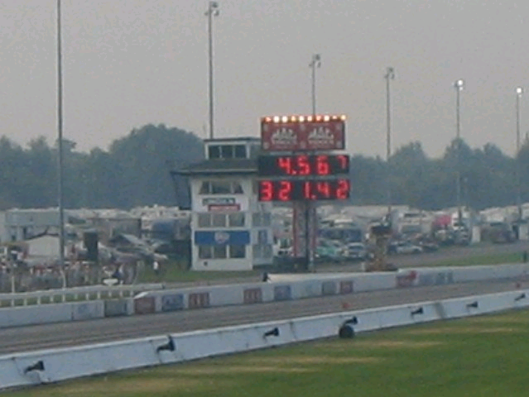
2. This shows time for a quarter mile, and speed after quarter mile (Indianopolis, 2004).

(Answer: That’s 321 mph, say 500 kph, after 4.5 seconds, about 120 kph per sec, or 120,000/3600 m sec per sec, say 30 m sec⁻², or 3g, very roughly.)

According to Wikipedia: A Top Fuel dragster accelerates from 0 to 100 mph (160 km/h) in as little as 0.8 seconds.
What is the g-force this driver experiences? (It’s 5.7g.) A production Porsche 911 takes 8 seconds to reach 100 mph.

