# Physics 1425 Spring 2010

## Problems to work in class:

### Lecture 2: Chapter 2

**37.** (II) A car slows down uniformly from a speed of 18.0 ms to rest in 5.00 s. How far did it travel in that time?

***** use average speed x time: 9 x 5 = 45m.

**38.** (II) In coming to a stop, a car leaves skid marks 85 m long on the highway. Assuming a deceleration of  estimate the speed of the car just before braking.

**\*\*\*\*\* use v2 = 2ax = 680. v approx 26.**

### Lecture 3: Chapter 2

**60.** (II) A stone is thrown vertically upward with a speed of 24.0 ms. (*a*) How fast is it moving when it reaches a height of 13.0 m? (*b*) How much time is required to reach this height? (*c*) Why are there two answers to (*b*)?

**\*\*\* v2 = v02 –** 2gy = 576 – 19.6 x 13, v = 17.9. Time required: 13/avge speed, or y = v0t - ½gt2.

**61.** (II) A falling stone takes 0.33 s to travel past a window 2.2 m tall (Fig. 2–44). From what height above the top of the window did the stone fall?

**\*\*\*\*\*** Call it y, falling time to top is t. y = ½gt2, (y + 2.2) = ½ g(t + 0.33)2.

Hence 2.2 = 0.33gt + ½ g(0.33)2, t = (2.2 – 0.54)/3.2 = 0.52 secs. y = 1.3m.

=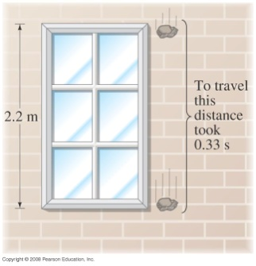

### Lecture 4, Chapter 3:

**15.** (II) The summit of a mountain, 2450 m above base camp, is measured on a map to be 4580 m horizontally from the camp in a direction 32.4° west of north. What are the components of the displacement vector from camp to summit? What is its magnitude? Choose the *x* axis east, *y* axis north, and *z* axis up.

**** draw picture, then *x* = -4580sin32.4, *y* = 4580cos32.4, *z* = 2450.

**22.** (II) (*a*) A skier is accelerating down a 30.0° hill at  (Fig. 3–39). What is the vertical component of her acceleration? (*b*) How long will it take her to reach the bottom of the hill, assuming she starts from rest and accelerates uniformly, if the elevation change is 325 m? Downward accn = 1.8sin30 = 0.9. 325 = ½ 0.9 t2, t = 26.9 secs.

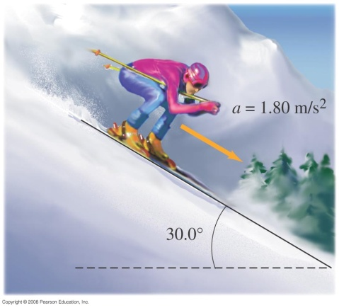

**5.Downward acD** (II) The summit of a mountain, 2L450 m above base c

### Lecture 5, Chapter 3

**45.** (II) A high diver leaves the end of a 5.0-m-high diving board and strikes the water 1.3 s later, 3.0 m beyond the end of the board. Considering the diver as a particle, determine (*a*) her initial velocity,  (*b*) the maximum height reached; and (*c*) the velocity  with which she enters the water. ***** her initial x-velocity is just 3/1.3 = 2.3 m/s. Her initial y-velocity must be upwards, to take that time to drop 5 m, y = v0yt – ½ gt2 = -5, t = 1.3, giving v0y = 2.5m/s. Height she reaches from v2 –v02 = 2gy, v = 0, gives 0.3m above the board. Her velocity entering the water needs only the vertical component: now vy2 = voy2 + 2gx5 = 6.25 + 98, vy = 10.2.

### Lecture 6, Chapter 4

**8.** (II) A 0.140-kg baseball traveling 35.0 m/s strikes the catcher’s mitt, which, in bringing the ball to rest, recoils backward 11.0 cm. What was the average force applied by the ball on the glove?

***** v2 = 2ax question, and F = ma, so F = mv2/2x = 0.140x352/2x0.11 = 780N.

**23.** (II) An exceptional standing jump would raise a person 0.80 m off the ground. To do this, what force must a 68-kg person exert against the ground? Assume the person crouches a distance of 0.20 m prior to jumping, and thus the upward force has this distance to act over before he leaves the ground.

**** ***** another v2 = 2ax question, but now we don’t need to find v2! He reaches v as his feet leave the ground, having (we assume) accelerated uniformly over a distance of 0.20m—but then he loses this same v over a distance of 0.80m, accelerating downwards at g. Applying v2 = 2ax to both parts, he must have been accelerating upwards at 4g before leaving the ground. Since his weight was there all along, his push on the ground must have been 5 times his weight.

### Lecture 7, Chapter 4

**Draw free body diagrams and say so!**

**54.** (III) Suppose the pulley in Fig. 4–46 is suspended by a cord C. Determine the tension in this cord after the masses are released and before one hits the ground. Ignore the mass of the pulley and cords.

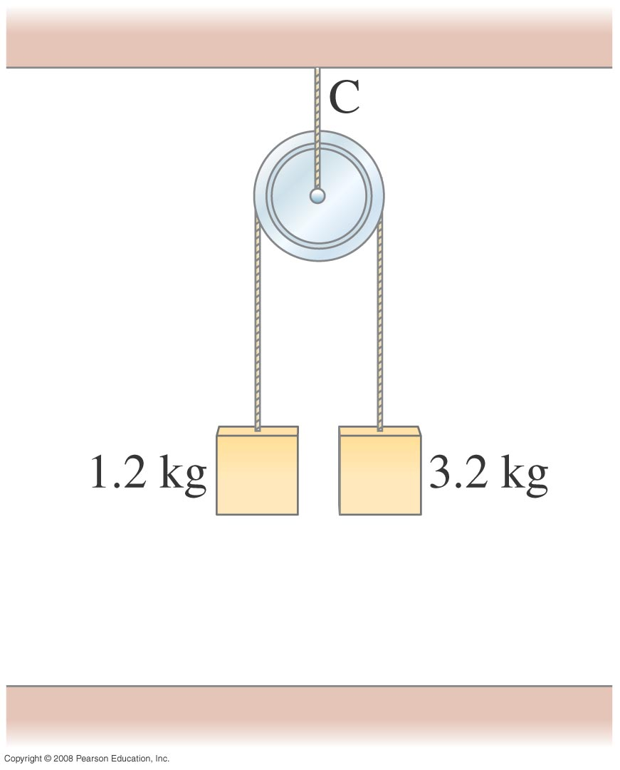

The tension in cord C must be twice the tension in the lower cord, since the pulley is not accelerating up or down.

Applying F =ma to the two weights gives:



**55.** (III) A small block of mass *m* rests on the sloping side of a triangular block of mass *M* which itself rests on a horizontal table as shown in Fig. 4–47. Assuming all surfaces are frictionless, determine the magnitude of the force  that must be applied to *M* so that *m* remains in a fixed position relative to *M* (that is, *m* doesn’t move on the incline). [*Hint*: Take *x* and *y* axes horizontal and vertical.]

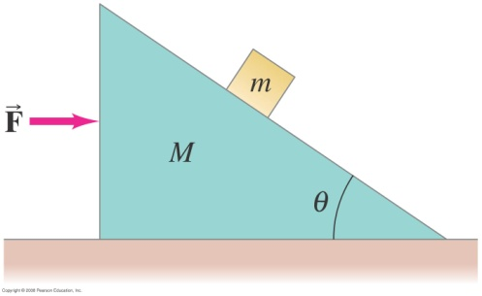

Assume the system is accelerating with the small block staying in place: the only forces on it are the normal force and gravity. The horizontal component of the normal force =ma, the vertical component mg, so tanθ = a/g, and a = F/(M +m).

### Lecture 8, Chapter 5

**12.** (*a*) Show that the minimum stopping distance for an automobile traveling at speed *v* is equal to *v*2/2*μ*S*g* where *μ*S is the coefficient of static friction between the tires and the road, and *g* is the acceleration of gravity.

(*b*) What is this distance for a 1200-kg car traveling 95 kmh if *μ*S = 0.65?

***** 95/3.6 = 26.4 m/s, *v*2/2*μ*S*g* = 54.7m (mass is irrelevant! Why?)

(*c*) What would it be if the car were on the Moon (the acceleration of gravity on the Moon is about *g*6) but all else stayed the same?

***** 6 times further.

**16.** A small box is held in place against a rough vertical wall by someone pushing on it with a force directed upward at 28° above the horizontal. The coefficients of static and kinetic friction between the box and wall are 0.40 and 0.30, respectively. The box slides down unless the applied force has magnitude 23 N. What is the mass of the box?

***** Normal force is 23cos28 = 20.3, static friction, upwards is 0.4 times this, 8.1. Upward component of push is 23sin28 = 10.8, add this to friction to get 18.9, this balances weight at point when sliding begins, so weight is 18.9/9.8 = 1.93kg.

**29.** (II) A child slides down a slide with a 34° incline, and at the bottom her speed is precisely half what it would have been if the slide had been frictionless. Calculate the coefficient of kinetic friction between the slide and the child.

**\*\*\*\*\*** using v2 = 2ax, acceleration is down by a factor of 4. Her acceleration was gsin34, the normal force was mgcos34, so friction contributes retarding force μmgcos34, this must be 0.75 of the gravitational force mgsin34 down the slope, so μ = 0.75tan34 = 0.51.

### Lecture 12 Chapter 7

**11.** (II) A 400-kg piano slides 4.0m down a 30° incline and is kept from accelerating by a man who is pushing back on it *parallel to the incline* (Fig. 7–21). Determine: (*a*) the force exerted by the man, (*b*) the work done by the man on the piano, (*c*) the work done by the force of gravity, and (*d*) the net work done on the piano. Ignore friction.

**\*\*\*\*\*** the force is 400gsin30 = 2000N, say (I’ve simplified the numbers, to show how to do it.)

The main point is that despite his efforts the man accomplishes negative work: his force is directed opposite to the actual motion! So in 4.0 m he does -8000J of work. Gravity—the force he’s opposing—does exactly that amount of positive work, no total work is done on the piano since it doesn’t accelerate, there’s no net force on it.

**38.** (II) If it requires 5.0 J of work to stretch a particular spring by 2.0 cm from its equilibrium length, how much more work will be required to stretch it an additional 4.0 cm?

****** The work to stretch a spring is proportional to the square of the distance stretched. So, if it’s 5J for 2 cm, it will be 45J for 6 cm, meaning an additional 40J.

**49.** (III) A 3.0-m-long steel chain is stretched out along the top level of a horizontal scaffold at a construction site, in such a way that 2.0 m of the chain remains on the top level and 1.0 m hangs vertically, Fig. 7–26. At this point, the force on the hanging segment is sufficient to pull the entire chain over the edge. Once the chain is moving, the kinetic friction is so small that it can be neglected. How much work is performed on the chain by the force of gravity as the chain falls from the point where 2.0 m remains on the scaffold to the point where the entire chain has left the scaffold? (Assume that the chain has a linear weight density of )

***** Notice that this is a complicated problem to analyze fully—as the chain moves down, more of it is pulling downwards, so the acceleration is increasing.

Fortunately, we’re not asked to think about this—we just want to know how much work gravity did from the initial moment, with 2 m on the table, 1m hanging, to the instant where all 3 m are first vertical.

This change is equivalent to taking the 2m on the table and moving that 2m part down by an average distance 2m. At 18N/m, that gives work 18x2x2 = 72J.

**48.** (III) A 3000-kg space vehicle, initially at rest, falls vertically from a height of 3200 km above the Earth’s surface. Determine how much work is done by the force of gravity in bringing the vehicle to the Earth’s surface.

***** (I changed the numbers slightly.) This spacecraft is subject to a varying force, so we have to do an integral to find the work done.

We’ll measure distances from the center of the Earth, call the variable *r*. In falling a small distance *dr*, gravity does work (*GMm*/*r*2)*dr*.

*rE* = 6.4x106 m, the initial height we took as 0.5*rE* above the surface. The work done by gravity on the way down is



Now , so this work is  (Note that if gravity stayed constant with height, it would be 